

eProject Java
Alluring Decor

Group 1
Group Member | Trinh Ngoc Phuc (Leader)  Ly Ngoc Bien  Le Thanh Hung  Luu Vy Thinh
Fanculty | Lê Văn Long
INDEX
1. Problem Definition 3
1.1. Problem Abstraction 3
1.2. The Current System 3
1.3. The Proposed System 3
1.4. Boundaries of the System 3
1.5. Hardware and Software Requirements 3
1.5.1. Minimum Requirements 3
1.5.2. Recommended Requirements 3
2. Customer Requirements Specification 3
2.1. Users of the System 3
2.2. System functions 3
3. Architecture & Design of Project 5
3.1. Data Flow Diagram 5
3.2. Entity Relationship Diagram (Table Design) 5
3.3. Database Structure 7
3.4. Screen Design 7
4. Task Sheet 8
5. Checklists 9
5.1. Check List of Validation 9
5.2. Submission Checklist 9

Problem Definition

Problem Abstraction
Our Client “Alluring Decors” is one of the upcoming Interior and Exterior Designers in the territory. They had been in to this profession since 5 years down the line. They deal with the Interior and Exterior Decoration of the houses, offices, shops, malls, etc. based on the contract that they had received from their clients.

The Current System
Alluring Decors, in general advertise about their work through the news papers, TV advertisements, hoardings, banners, and through the internet (some other advertising websites) for which they should have to incur certain amount for advertising. Also for advertising they cannot go up to a full extent, i.e., there is a limitation in advertising either due to costing or due to the limitations of advertisement.

The Proposed System
The Management of Alluring Decors had come up with the an idea through which they can give a much more insight about their work by including a website for their own, in which they can advertise with a full span, with images, etc. Also they introduce new tasks and they can advertise the accomplished tasks, etc. So they approached us with their idea, so that we can help them by developing a site for them through which they can implement their ideas.

Hardware and Software Requirements

Minimum Requirements
Hardware Requirements:
• Pentium III 2.6Ghz or over.
• Ram 512MB
• Hard disk require over 1 GB free
Software Requirements:
- Windows 2000

Recommended Requirements
Hardware Requirements:
• Pentium IV 2.6Ghz or over.
• Ram over 512MB
• Hard disk require over 1 GB free

Software Requirements:
• Microsoft Windows 2000/XP/ Vista/ Windows7.

Customer Requirements Specification

Users of the System
- Admin
- Client
- Guests

System functions
Users functions:
- Order managements:
  - View list of the customer, order details.
  - Update status of order, address change.
- Account department:
  - View order details, customer details.
  - View/Update/Delete account detail.
- Dispatch team:
  - View order details, custormer details.
  - Update orders status.
- Call center:
  - Search.
  - Lodge and update complaint.
  - Check complain status.
- Technical support:
  - Track comlaint
  - Update complaint status
  - View complaint
Admins function:
- View details order, custormer, and uers
- Update/Delete/Cancel users

Architecture & Design of Project

Data Flow Diagram

Level 0:

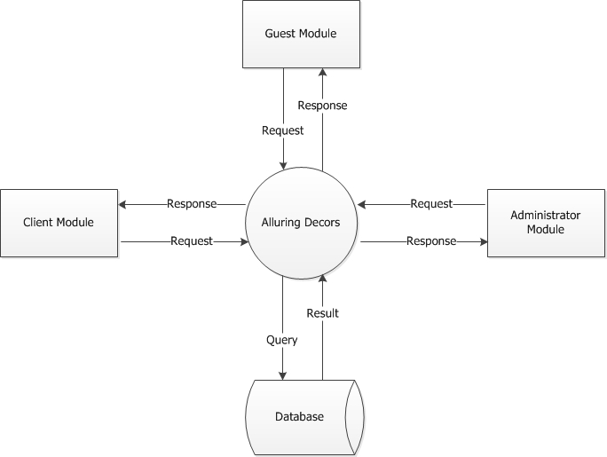

Add Bill:

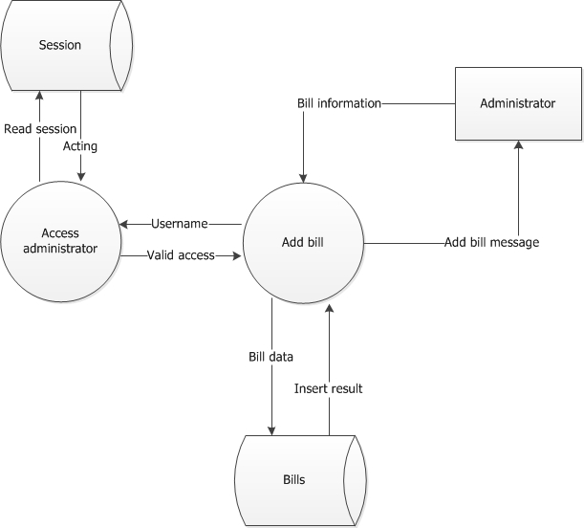

add-payment:

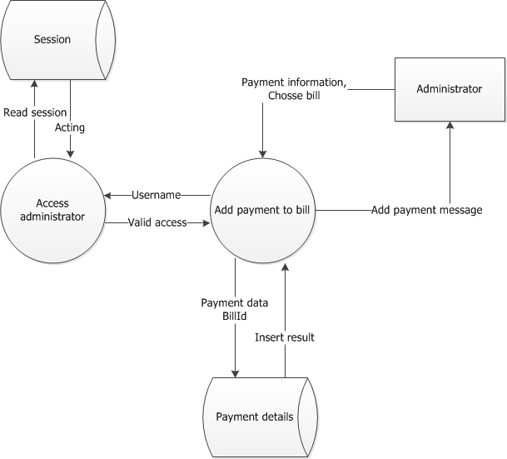

add-project:

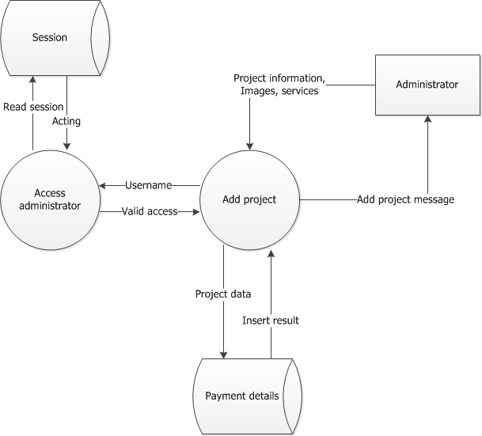

add-services:

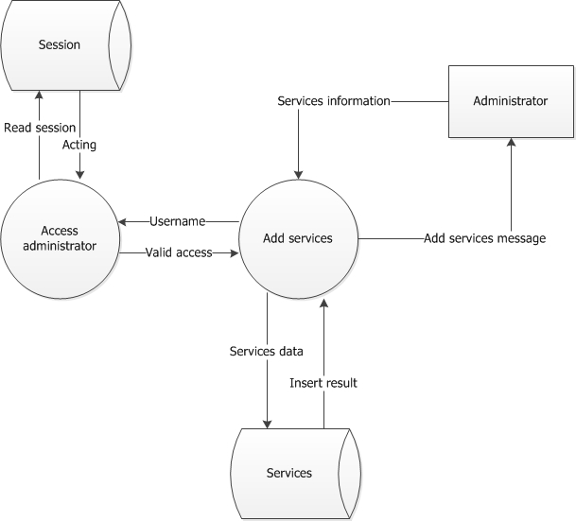

delete-payment:

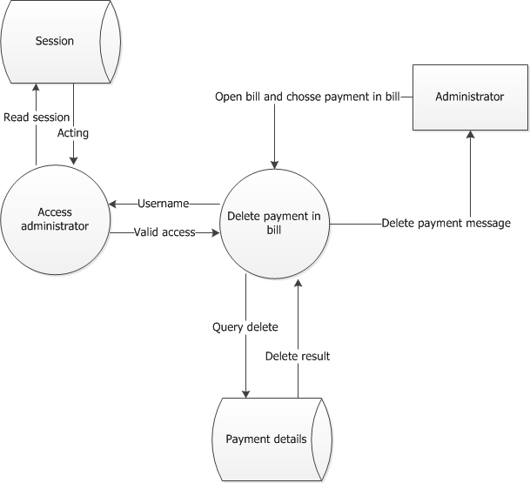

delete-payment:

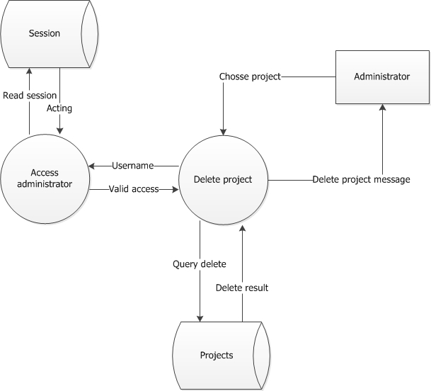

edit-payment:

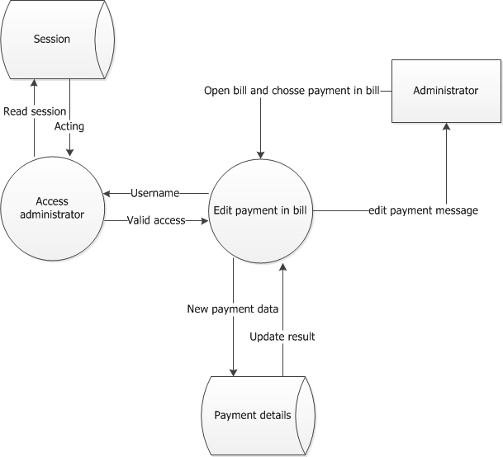

edit-project:

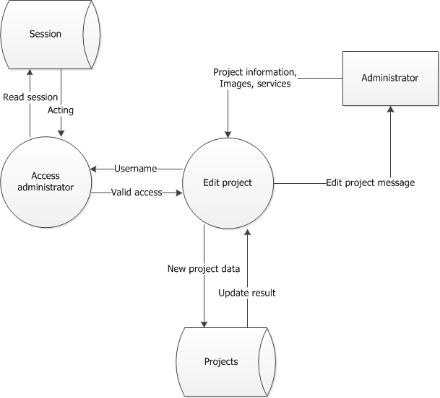

Feedback:

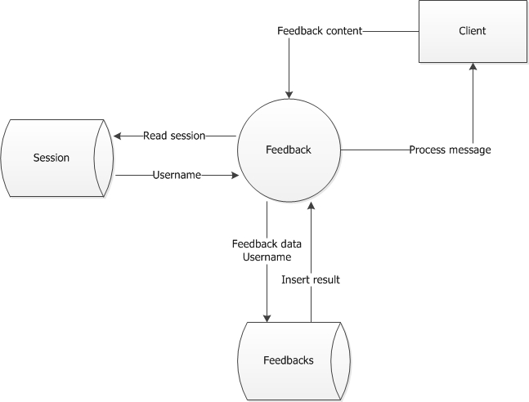

Login:

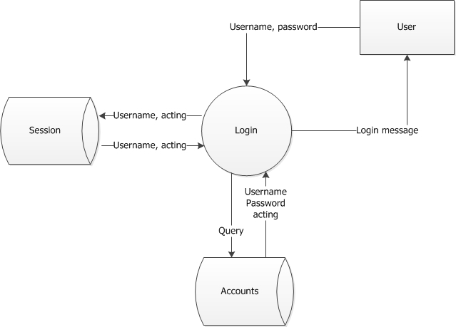

Register:

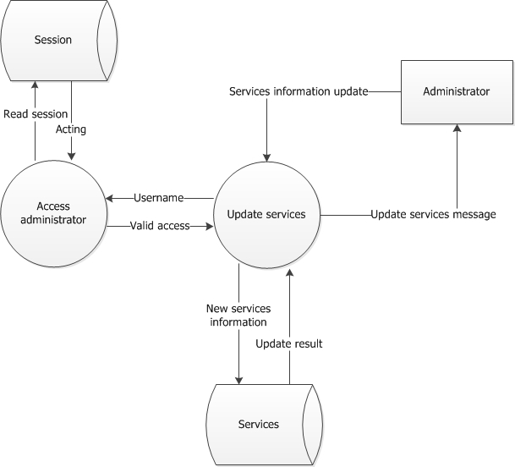

update-services:

Entity Relationship Diagram (Table Design)

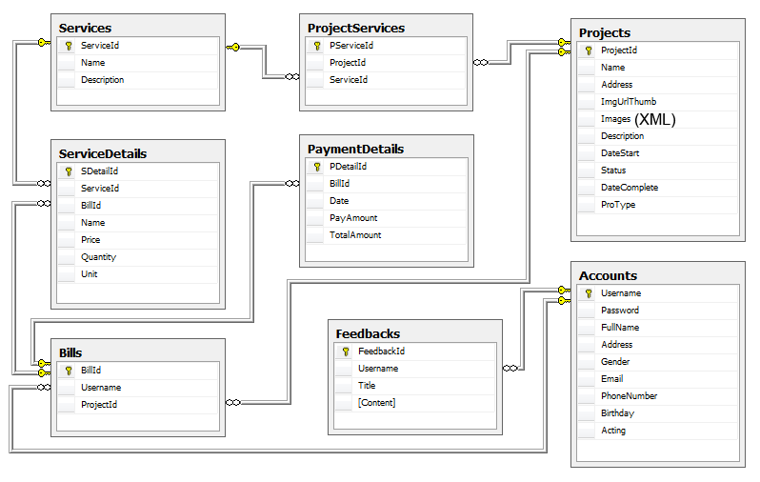

Database Structure
    - Account:

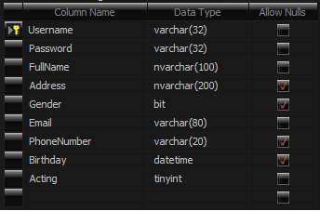

    - Payment Details:

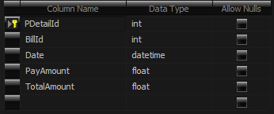

    - Project:

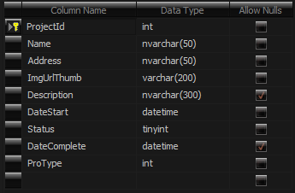

    - Services:

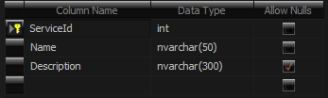

    - Services Details:

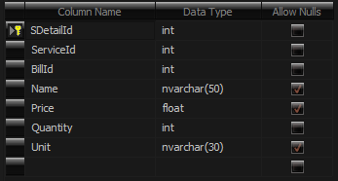

    - Project Service:

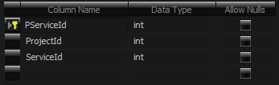

    - Feed Back:

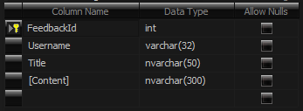

    - Bill:

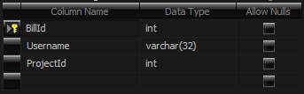

Task Sheet
Document | Start Time | Finish Time | Implemented by | Evaluation
Document | 27/8/12 | 05/09/12 | Lưu Vỹ Thịnh | 30%
Document | 27/8/12 | 05/09/12 | Lý Ngọc Biên | 30%
Document | 27/8/12 | 05/09/12 | Lê Thanh Hùng | 20%
Document | 27/8/12 | 05/09/12 | Trinh Ngọc Phúc | 20%
Analysis | 27/8/12 | 05/09/12 | Lưu Vỹ Thịnh | 30%
Analysis | 27/8/12 | 05/09/12 | Lê Thanh Hùng | 30%
Analysis | 27/8/12 | 05/09/12 | Lý Ngọc Biên | 20%
Analysis | 27/8/12 | 05/09/12 | Trịnh Ngọc Phúc | 20%
Design | 27/8/12 | 05/09/12 | Lưu Vỹ Thịnh | 30%
Design | 27/8/12 | 05/09/12 | Lý Ngọc Biên | 30%
Design | 27/8/12 | 05/09/12 | Lê Thanh Hùng | 20%
Design | 27/8/12 | 05/09/12 | Trịnh Ngọc Phúc | 20%

